**Mass-Spring Simulator – User’s Manual**

**Installation**

*NOTE: If you have Python 2.7 installed and Pip can be run from anywhere (i.e the environment variables know where Python is), you don’t need to follow the first few steps.*

To be able to run this software, you should have Python 2.7.14. The software may work on other versions, but it was developed on and for 2.7.14. Download and install the windows version 2.7.14 from:

<https://www.python.org/downloads/>

After installation, navigate to your system environment variables (on Windows 10, search in the start menu “Edit Environment Variables”). Edit the Path variable to include the Python27 directory, as well as the Scripts folder (by default it would be C:\Python27 and C:\Python27\Scripts). This is so that you can use Python and any scripts (like Pip) from anywhere on your computer.

*Installing the proper libraries.*

If you open a command prompt window and type pip, you should not receive any errors, but should see a list of commands and descriptions. If you get an error like “pip is unrecognized” then you either have the wrong version of Python or you didn’t set up your environment variables correctly. It is recommended that you check the environment variables, and also check Python27 installation folder to make sure there is a Scripts folder that contains Pip. If not, you should uninstall Python and install it via the link above.

Once confirmed that pip works, enter the following commands in cmd:

pip install numpy; pip install pyside; pip install matplotlib; pip install pygame

Make sure each one is done running before typing the next one. This should install all the external libraries needed for the program. These steps are super important, and the program won’t run without success of these steps. **If you have trouble with getting the software to run, EMAIL** **ssraisbe@edu.uwaterloo.ca.**

**Using the Software**

To use the software, run the batch file titled MassSpringSim.bat. This will run GUI204.py, which is the user interface for the software.

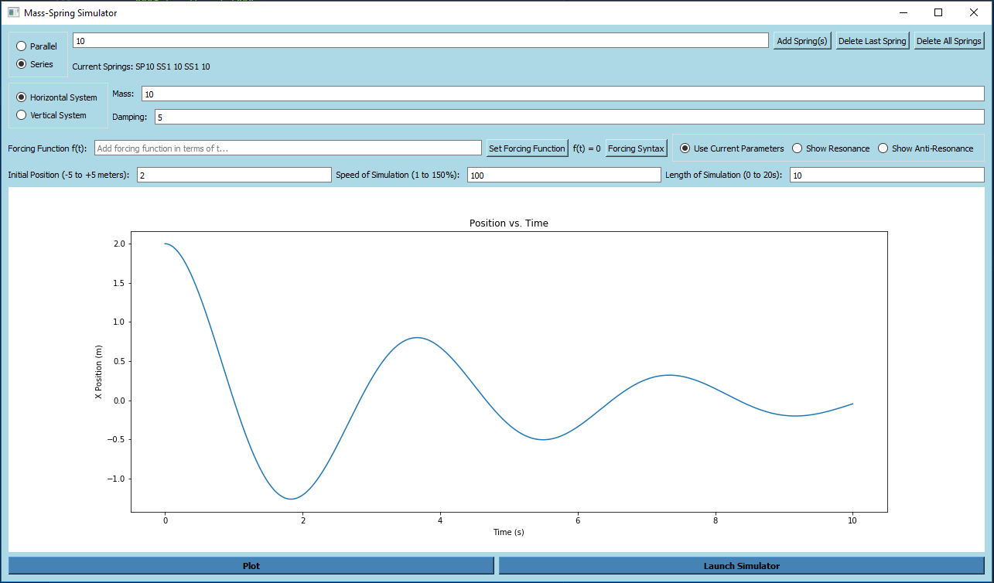

*Adding Parameters*

To add springs, you can type their stiffness values into the textbox at the top, along with checking the appropriate circle to add the springs in series or in parallel. Typing multiple values separated by spaces will add a spring for each value. For example, adding something like “50 50 50” with the Parallel circle checked will produce three springs in parallel, each with a stiffness of 50. The same input, with Series checked, will produce a set of three springs, connected in series, each with a stiffness of 50. You MUST add at least one spring with an acceptable stiffness to run the simulation.

Other parameters, such as mass, damping and initial position can easily be added/altered. If you wish to add a forcing function, type it in. The program supports sine, cosine, tangent, and exponentials (click the help button for formatting tips). If, perhaps, you would like to see an example of resonance or anti-resonance, check one of those circles. This will use pre-set parameters that show how a system will be affected by an external force to continuously keep growing or decreasing in amplitude.

Finally, the speed of simulation and length of simulation can be assigned by the user. The speed of simulation allows you to play the simulation in fast or slow-motion with a maximum speed of 150%. The length of the simulation, of course, specifies how much time in seconds you would like to see of the simulation run for.

*Plotting and Simulating*

By default, the simulation will show a mass-spring system moving in the horizontal direction. If you would like to see a hanging mass, select the Vertical Spring circle. The same parameters will be used in either case.

After a valid set of parameters have been entered, clicking the “Plot” button will generate a plot of the mass’ position with respect to time directly in the GUI. Clicking “Launch Simulator” will pass all the necessary parameters to spring.py, which will run a simulation of the physical system. This simulation can be replayed, or closed if you wish to make changes to parameters.